Pikes Peak Section of the Society of Women Engineers
16th Annual Awards Luncheon AND
Volunteer Recognition

Members, Spouses, Friends, Volunteers, Science Fair Winners,
Scholarship Recipients, and Scholarship Sponsors are invited to Attend

Speaker: Pamela Strong
SWE-PPS is honored to have Pamela Strong as our keynote speaker for this event. Pamela is currently working for ULA in Denver as the non-metallics/composites material and process engineering focal for the design and manufacture of the Delta and Atlas rockets. Her responsibilities include implementing metal replacements with composites to reduce weight and cost. She is the 2007 Society of Women Engineers Achievement Award recipient and we are delighted to hear about her career.

Awards Presenters: Pikes Peak Section Officers and the Scholarship Committee

Date/Time: Saturday, July 10, 2010 at 11:30 a.m.

Place: Marigolds Café
4605 Centennial Blvd.
Colorado Springs, CO

Menu: Choice of Entree:

- Salad of Mixed Greens with Salmon,  with honey mustard dressing and bread  - Beef Bourguignon with mashed potatoes and bread  Served with: Tea, Coffee or Lemonade and Dessert  Price: $22.00 includes tip and tax | 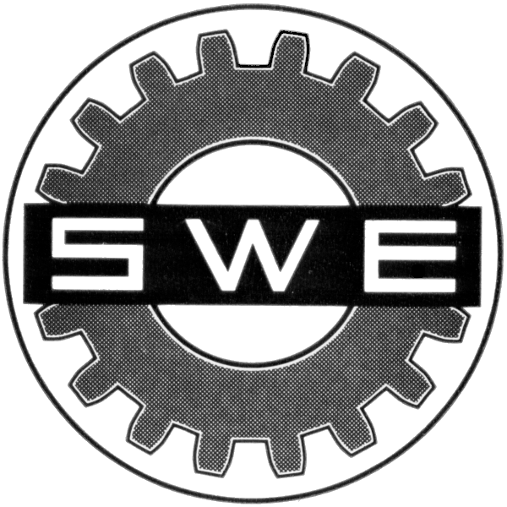

RSVP by noon Thursday, July 8th to Brenda Wolfe at brenda.wolfe@metso.com (preferred) or (719) 237-5913. Please leave your name, phone number, and choice of entree.

Please note that a reservation is a financial commitment. We have to guarantee the number of people attending the luncheon. If you make a reservation and do not attend, you will be billed.

